Container Deposit Scheme - Northern Territory

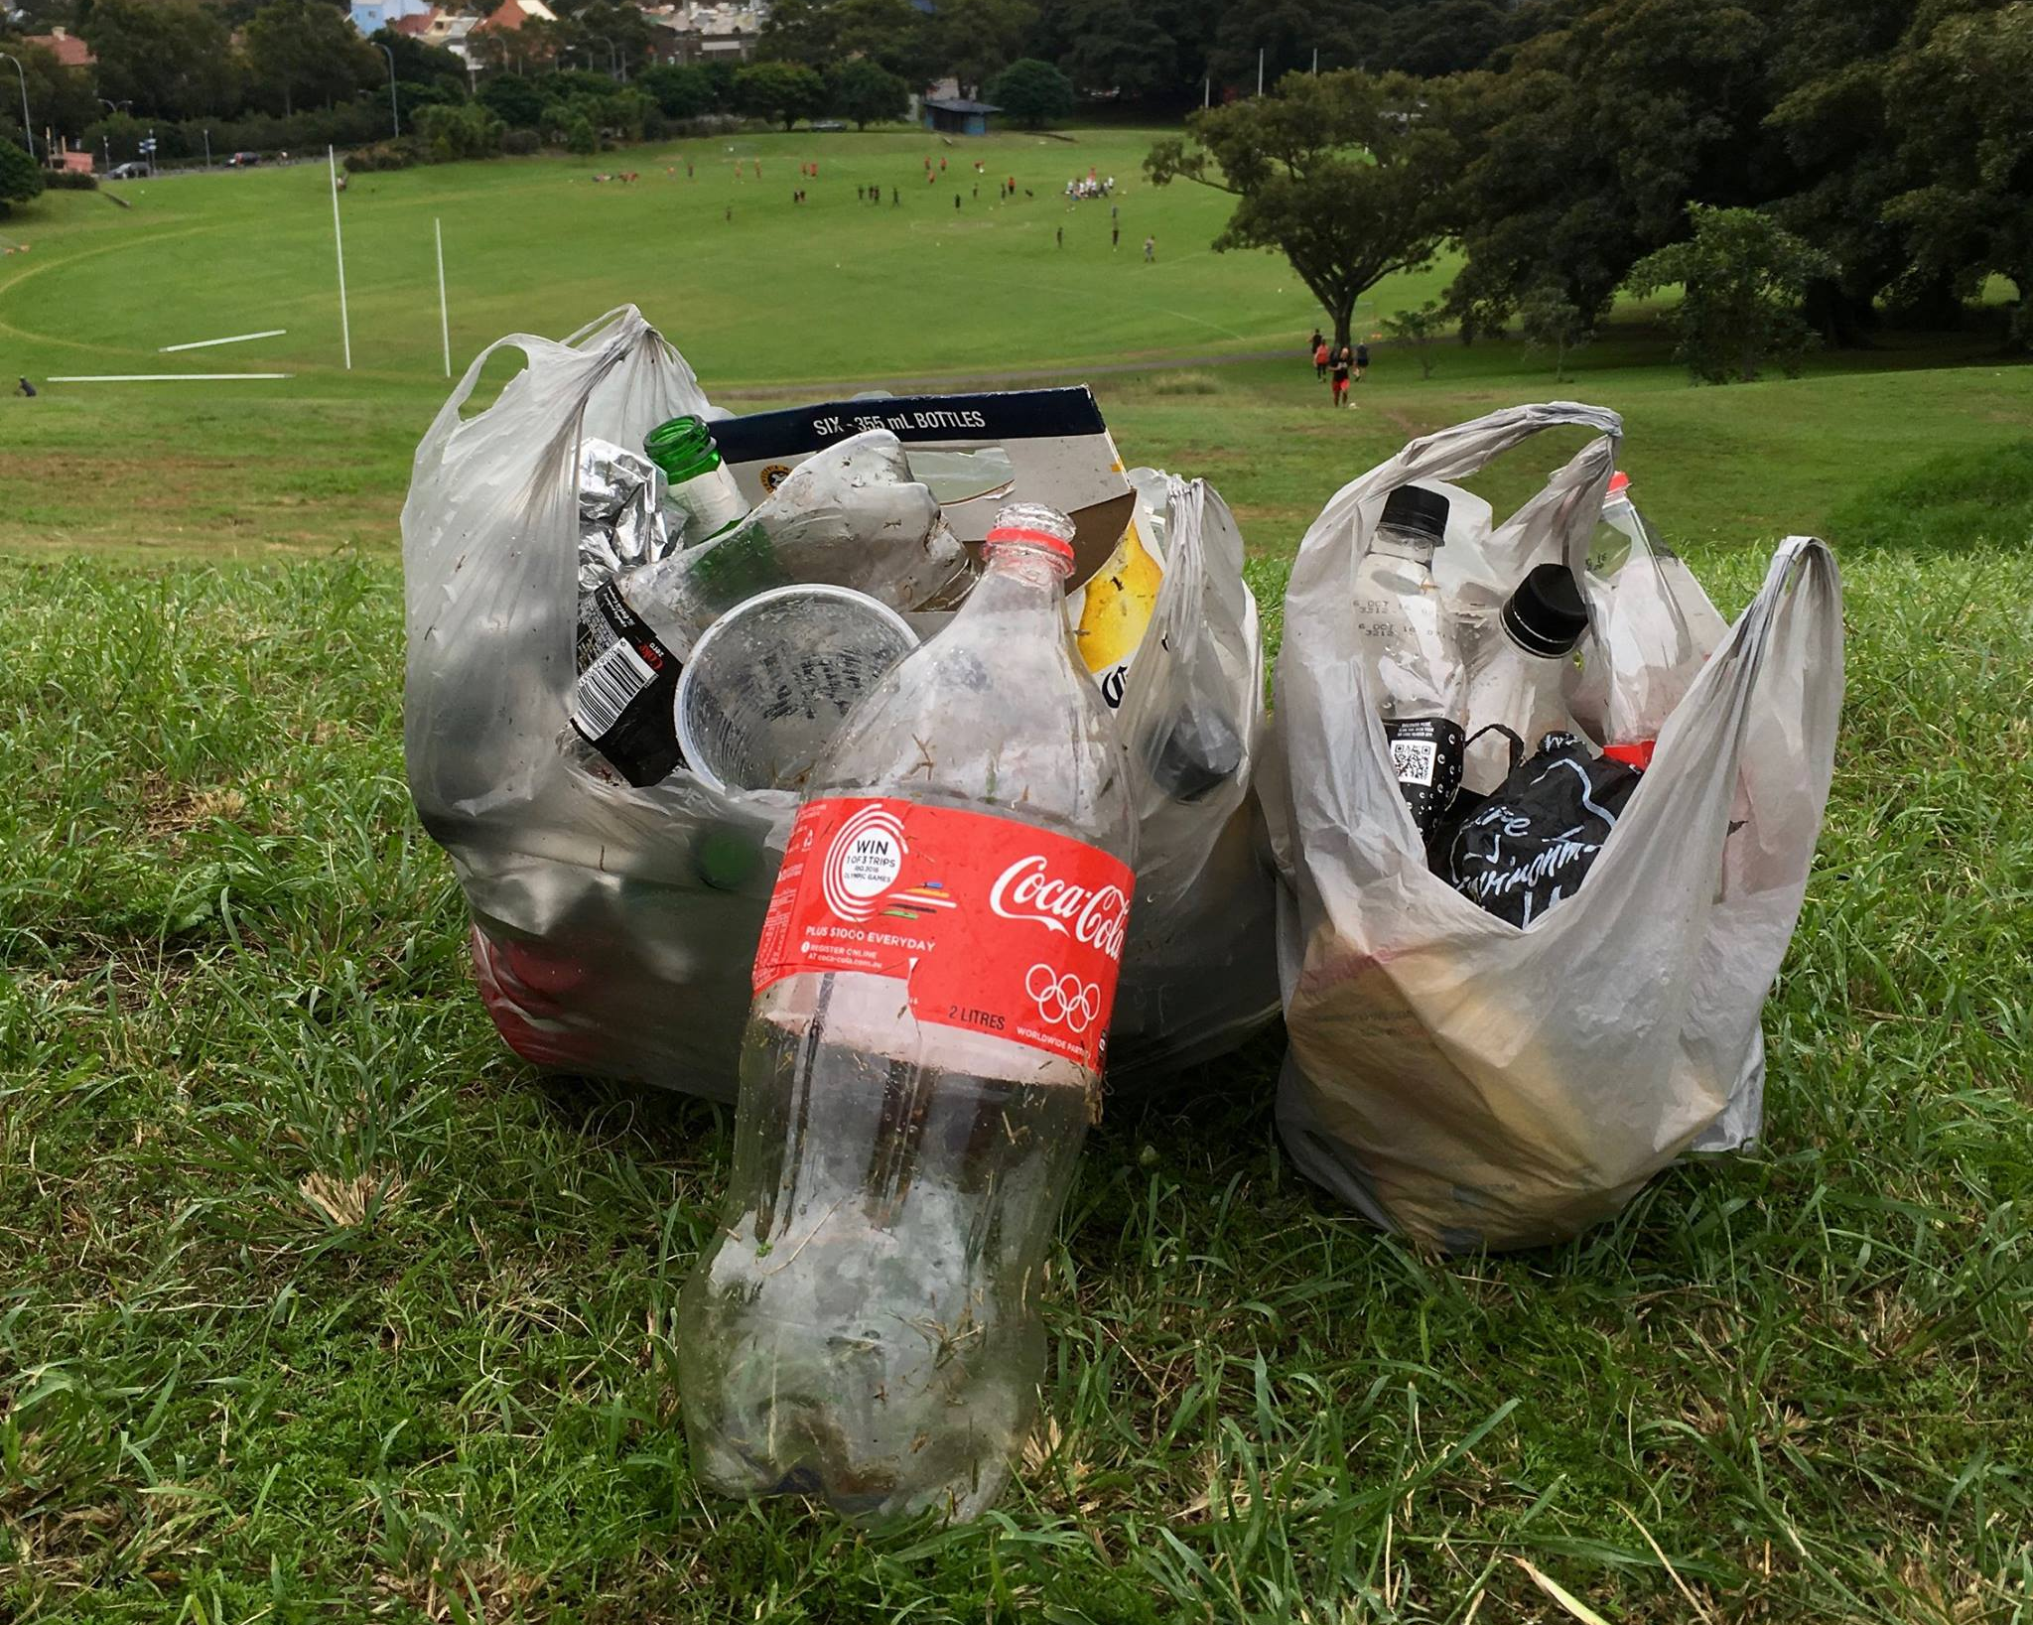
The container deposit scheme (CDS) is one of the first pieces of environmental legislation to focus on the ‘polluter pays’ principle, where beverage suppliers that bring eligible containers into the NT are responsible for funding the 10-cent refund as well as associated costs. If someone discards an empty container they forfeit the right to the refund and someone else would benefit by picking it up and collecting that refund. The Northern Territory launched its scheme in 2011.
The NT CDS provide a financial incentive to reduce litter

The benefits

With waste becoming a bigger and bigger problem, container deposit schemes provide a financial incentive to reduce litter, leading to cleaner beaches, waterways, parks and streets, and means less recyclable materials are sent to landfill. Containers currently regulated by the NT CDS cover up to 90% of beverage container litter observed in the NT litter stream and it is estimated between 50-60 million containers could be captured for resource recovery in the NT. Recycling saves energy, water and natural resources.

What’s covered? | What’s NOT covered?
- Carbonated soft drinks, 3L or less  - Non-carbonated, soft drinks: including (but not limited to) fruit/juice based drinks (containing less than 90% juice), ‘sports’ drinks, ‘vitamin’ drinks, ‘energy’ drinks, ready to drink cordials, 3L or less  - Pure fruit/vegetable juice: means a liquid at least 90% of which is fruit juice and/or vegetable juice.  - Flavoured milk, less than 1L  - Water: plain, still or carbonated spring water, mineral water and any other water intended for human consumption, less than 1L  - Beer, cider and mixed drinks, 3L or less | - Unflavoured milk (cartons, glass or plastic)  - Concentrated fruit and/or vegetable juice intended to be diluted before consumption  - Health tonic included on the Australian Register of Therapeutic Goods  - Cordial (undiluted)  - Glass wine and spirit bottles
How to recycle

Collection Depots are the public drop off points for the NT CDS which pay the 10-cent refund for each container purchased in the NT. You can ensure you receive your refund by not crushing containers, keeping the lid on, presenting relatively clean containers and sorting containers into material types.

If you return more than 1,500 containers to a Collection Depot within any 48-hour period, you will need to sign a declaration form stating that the containers were purchased in the NT and were purchased after 3 January 2012.

What happens to the containers

At the collection depot, containers are sorted by beverage supplier and material type and then sent to NT CDS Coordinators that pay for the deposit and a handling fee. The Coordinators have waste management arrangements with beverage suppliers. The containers are then sent on for recycling, re-use or appropriately disposed.

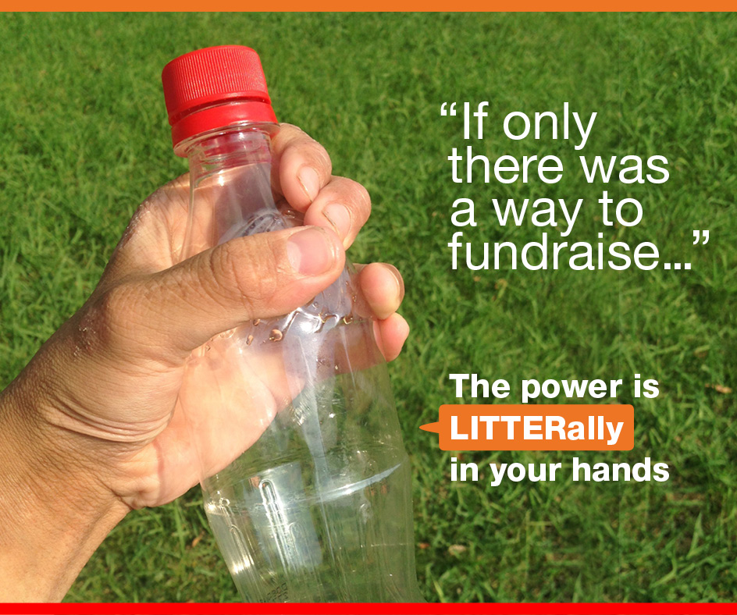
Take Action
Communities can fundraise using the NT CDS

The CDS is more than just a fundraising activity – it’s a fantastic way to get kids and the community involved to help look after the local environment.

- Community groups, sporting clubs and schools can get involved by establishing donation collection points for approved containers. For more information, phone (08) 8924 4218 or email containerdeposit@nt.gov.au.
- Find your closest collection depot at RecyclingNearYou.com.au [LINK TO COME]

More Information

NT Environment Protection Authority

NT CDS Annual Report 2015-16

